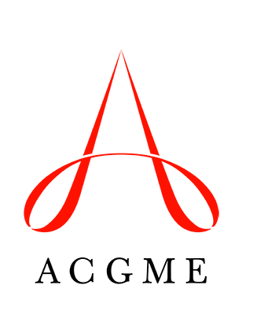
Requests for Changes in Resident Complement
Review Committee for Otolaryngology - Head and Neck Surgery

This Review Committee approves:

- Increases in resident complement
- Complement by year and total

A temporary or permanent increase in resident complement requires prior approval of the designated institutional official (DIO) and must be reported to the Review Committee through the ACGME’s Accreditation Data System (ADS). An educational rationale must be included with the request. Review Committee staff members will contact the program if additional information is required to process the request.

To officially initiate a change in the approved resident complement, program directors must log into ADS and select “Complement Change” from the right panel under the “Program” tab. All complement change requests will be electronically sent to the DIO for approval. After the DIO has approved the request, the materials submitted in ADS are forwarded to the Review Committee for consideration. The Review Committee Executive Director will notify the program of the Committee’s decision.

Programs must hold a status of Continued Accreditation to be considered for a complement increase. Programs with statuses of Continued Accreditation with Warning, Initial Accreditation, Initial Accreditation with Warning, or Probationary Accreditation are not eligible for a permanent increase. A site visit may be required for complement change requests, depending on the details of the request.

The following documents/information are required to complete a request for an increase in complement (instructions are also provided in ADS):

- Educational rationale for the change
- Major changes in the program since its last review
- Response to previous citations
- Current block diagram
- Proposed block diagram

All required materials must be received by the agenda close date of a scheduled Review Committee meeting; these dates are posted on the Otolaryngology - Head and Neck Surgery section of the ACGME website.

